Hall 03.1 Stand C 71

Per ulteriori informazioni: http://www.boschpackaging.com

Hall 06 Stand A 76

• Roller Compactor WP 120
• Roller Compactor WP 120 with isolator
• Roller Compactor WP 200
• Drive unit SKM/NR with rotor fine granulator RFG 150 DA
• Drive unit SKM/NR with grater/shredder PGS 165 A

Per ulteriori informazioni: http://www.alexanderwerk.com

Hall 06 Stand C 23

• L10
• L100HCVP Vacuum dryer/mixer
• L500

Per ulteriori informazioni: http://lindor.nl

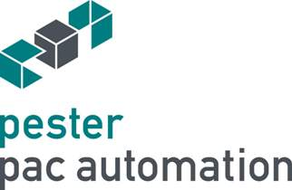 | Hall 03.1 Stand G 71  • New side loading case packer PEWO-form SLC in a new state-of-the art pharma design in line with a two-station palletizer PEWO-pal 5.2 Compact incl. Track & Trace integration  • New HMI with 3D visualization and OEE monitoring  • The highest form of pharma safety with pharma module software  • New case magazine ready for automatic format change  • Palletizer with space-saving slip sheet magazine and high operating safety technology for connection to AGV systems  • Interactive 3D visualization  • Predictive maintenance with PI-Historian data monitoring  • Real-time assistance with Augmented Reality  • Real-time and mobile OEE machine performance monitoring  • Worldwide secure Remote Service  • Spare part installation guidance via QR Code  Per ulteriori informazioni: http://www.pester.com

